6A^{th} Grade: Unit 10, Lesson 6
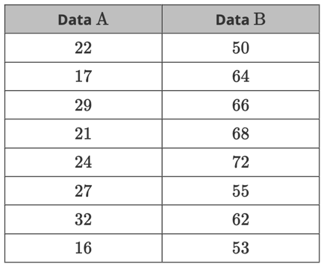

- What is the range of the Data A dataset?

16

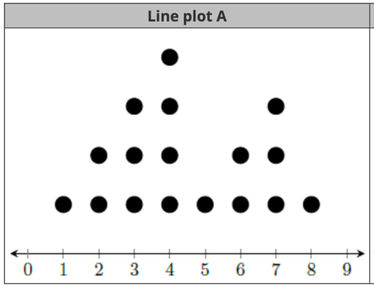
- What is the value in Line plot A with the most occurrences?

4

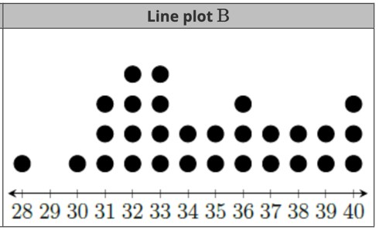
- What is the range for line plot B?

12

